ITM University Gwalior
School of Computing and Intelligent Systems
Project-Based Learning (PBL)
Mini Project Report — Submission Format

Course: Data Analytics Using Python
Course Code: CSL0312
Program: B.Tech. CSE (Artificial Intelligence & Machine Learning)
Semester: III Section:
Academic Session: July–Dec 2026
Project Details
Project Title: CRIME HOTSPOT ANALYSIS & IDENTIFICATION
Domain (as per Section 6): crime and public safety
Team Leader Name & Roll No.: Aditya kumar savita [BETN1AI25131]
Team Member Name & Roll No.: Vansh sikarwar[BETN1AI25135]
Team Member Name & Roll No.: Yashish singh bhadouriya[BETNAI25136]
Faculty Mentor: DR. Sanjay jain
Date of Submission: 16-10-2026

1. Introduction & Problem Statement
In India crime is a major concern and this is the main problem that occurs is to reduce this crime and how can we help to reduce and overcome this because this is a part of safety so our project is based on that problem . The background of our project is to determine and analysis the data and make it in from of graph and understandably from of data through which we can understand that which city has high crime rate and low crime rate and why crime is boosting in these cities so from there the government bodies can understand and come to an end the solution of this problem . The real world problem which being addressed with this is the increase in crime india having crime is the biggest real-world problem and to address this we have to make such kind of system that work on data to provide correct depiction of data which includes crime rates why they were happening and what we need to stop them so our project is to collect data and after put some opretion in that data after analysing it through the data reading we can decide the cause of crime why it happening and where when is occurs so my and my team work is only is to understand data and make it in this from that government officers like police and others can esaly understand that crime data analysis and find the cities and town that has high and low crime rates so that they can work on it according to it the significance and the scope of the project is that it can help government to understand through a well determined data that what we need and to end the crime issue and this thing only happens when we have such ammount of correct and arrangend data through which police can understand that what they need to overcome that problem.This project is important because analyzing crime patterns can provide useful information for understanding public safety concerns.
We use pyhton labs and jupyter notebook for the codes to clear clean data to make graphs to understand the cause of the problem because it is esay to answer when the problem is very ubderstanable thhrough gaphs we understand high and lows crime rates tools and cause through which crime happens age , gender , place etc of the coulprit that is the cause of crime and The results will be presented through charts and a simple dashboard. it will not predict future crimes or use artificial intelligence or machine learning.The project will use only basic data analytics techniques in Python to analyze data and find crime patterns, and give a solution. No advanced AI or machine learning techniques will be used.
2. Dataset Description & Source
Dataset Name: crime_dataset_india.csv
Source / Organization: From Kaggle by Sudhanvahg
Dataset Link (URL): https://www.kaggle.com/datasets/sudhanvahg/indian-crimes-dataset
Type of Dataset: ☐ Public ☐ Private ☐ Self-Collected
Number of Records: ____________________
Number of Attributes/Columns: _______________
Confirm the dataset meets the minimum quality criteria specified in Section 7 of the PBL guidelines: at least 500 records, at least 5 attributes/columns, and minimal missing values (or a documented justification if extensive cleaning was required)
Yes our dataset meets the minimum quality criteria specfied in section 7 because it has contain 40160 records and 14 attributes which is much more then the given one and it contain more than thousands of missing values in two of there section .

☐ Dataset meets minimum quality criteria (Section 7)
Brief description of attributes/columns:
The attributes and columns in my dataset are such as as given below each and every coloumn indicates crime related things such as report number city crime code etc.. there are 14 attributes in my dataset as given below.
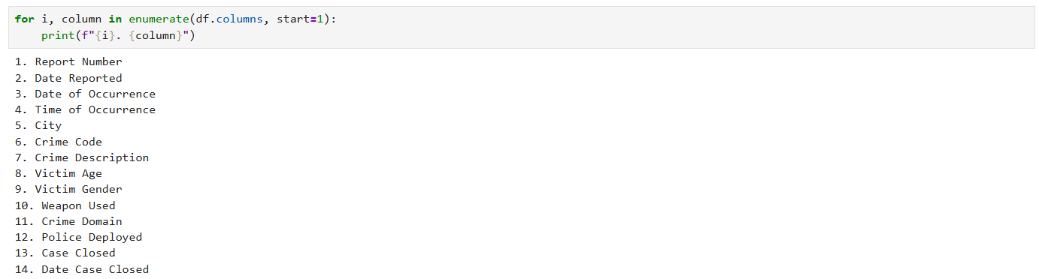
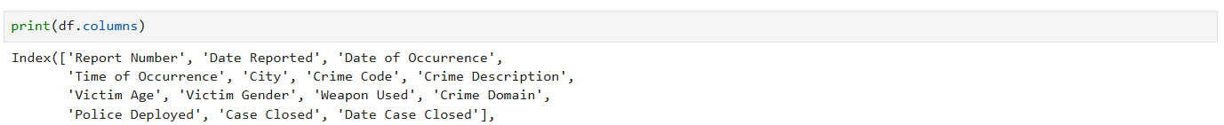

3. Data Cleaning & Preprocessing
Data inspection-
Here we use data inception we work on dataset in jupyter notebook and clean and prepossesing it these are all steps mention we done on this , In this section, we cleaned and prepared the dataset for analysis. We checked missing values, duplicate records, blank values, and invalid data. We also converted date columns into the correct format and checked unusual values in the victim age column. These steps helped us make the dataset more organized and ready for further analysis.
List of susbstances in data - Dataset load -
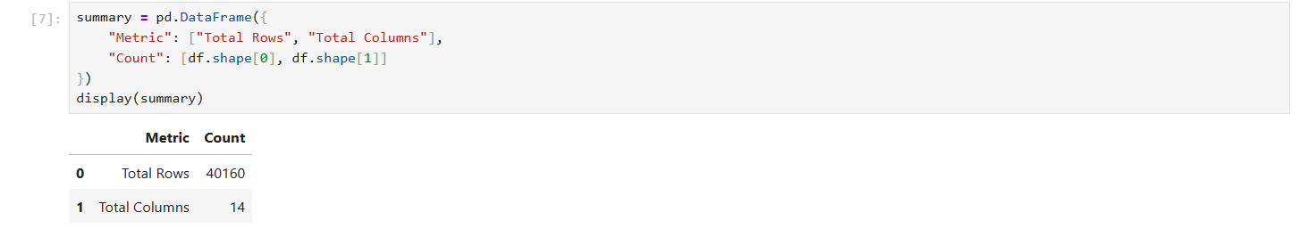
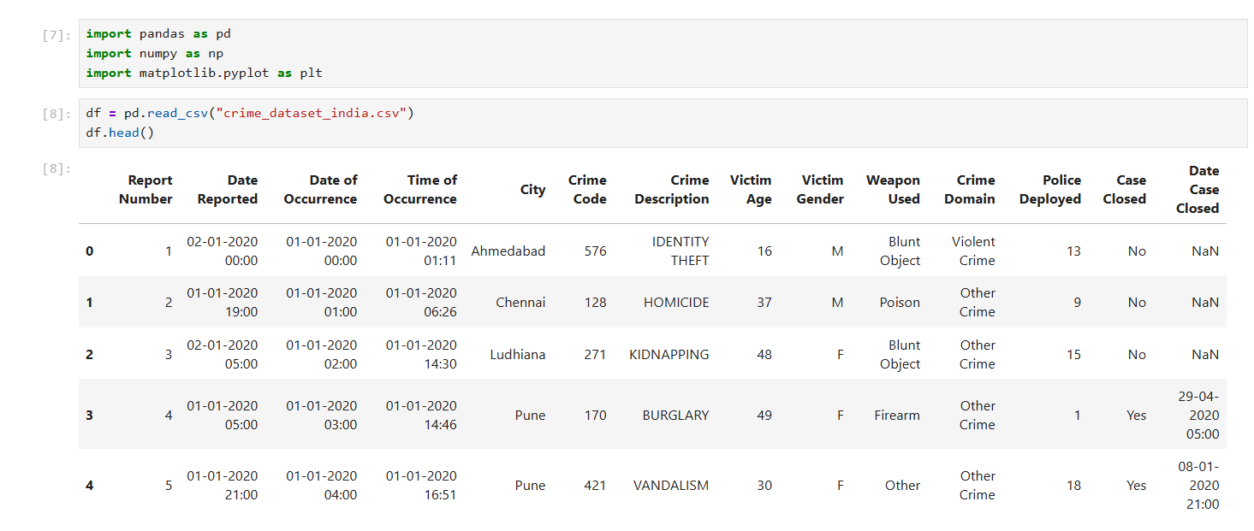
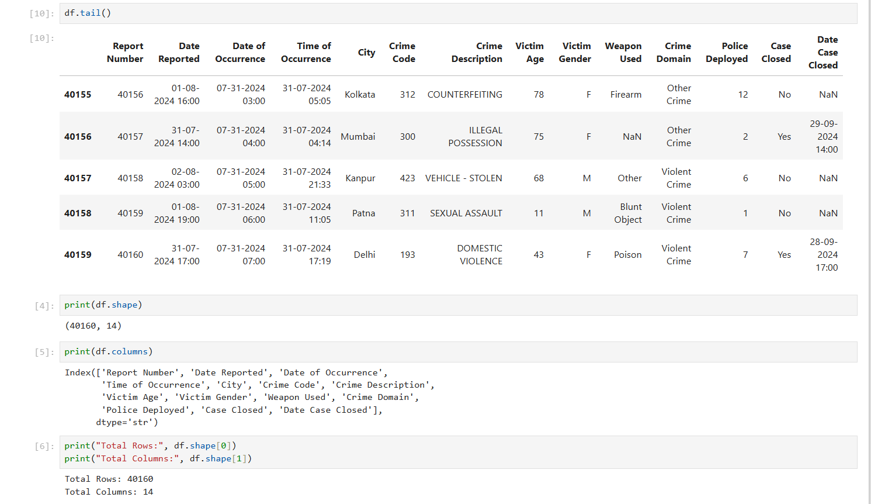
City of crime which city has high crime rate-
There is the name of cities which have highest crime rate head.(10) is used for determine this is select top 10 cities with highest crime rate value_count is used to count the values that which city has how many crimes.
Date reported , date of occurrence , date case closed and missing values of it -
To count date of crime attributes We checked the date columns in our dataset to see if the dates were in the correct format and if any values were missing. We converted the date columns into datetime format using Python so that we could use them for further analysis. We found that there were no missing values in Date Reported and Date of Occurrence. However, Date Case Closed had 20,098 missing values. These missing values were present in cases marked as "No" in the Case Closed column. We kept these values as they were because open cases did not have a closing date. This helped us understand the dates properly and use them for our analysis.

Handling missing values -
To handling all the missing values my dataset contain is use we use isnull().sum() the two attributes wepon used and date case closed has missing values because there is a big reson behind it as we know mostlty crime are not done by any type og wepon ex- Rape , chokeing the neck or kill by fighting and many cases are still pending they were not solved so that’s why these two attributes has missing values.
Duplicates -
No duplicate has been found. We checked the dataset for duplicate records to find the same record was not repeated. We used Python to find duplicate rows in the dataset. The output showed that there were 0 duplicate records out of 40,160 rows. This means that no complete duplicate rows were found in the dataset. This step helped us check the data and avoid repeated records during the analysis.
Outliers-
In this case age may or may not be an outlier because it can never be 0 or less then it so we find outliers which is shown below with its statsics logic mean median mode of age Outlier Analysis: We checked the Victim Age column to find any unusually low or high values using the IQR method. We calculated Q1 as 27 and Q3 as 62, and the IQR was 35. The lower limit was -25.5 and the upper limit was 114.5. We found that there were no outliers in the Victim Age column. This means all the age values were within the limits calculated by the IQR method. This step helped us check if there were any unusual age values in our dataset.
Data types -
We checked the data types of all columns in our dataset using Python. We found that some columns contained text data, some had numerical values, and the date columns needed to be converted into the correct date format. We converted the Date Reported and Date of Occurrence columns into datetime format so that we could analyze the dates properly. This helped us work with the data easily and perform further analysis without date format problems.
Counting blank and negative values means unvaild values -
we need it beacause to find attributes which have blank and negative values the out it is given on next page of it we use head(10) because to display top 10 most values of it We checked the dataset for blank values and negative values to find incorrect data. We found that there were no blank strings in the text columns and no negative values in the numerical columns we checked. This means the checked columns did not have these types of invalid values. This step helped us check the quality of our dataset before doing further analysis.
Relation btween date of case closed and case closed -
Realation btween the date of case closed and casees that has been closed or not. We checked the relation between the Case Closed column and the Date Case Closed column. We found that all cases marked as Yes had a closing date, while all cases marked as No had no closing date. There were 20062 closed cases and 20,098 open cases in the dataset. This check helped us understand the case status and find if the closing dates matched the status of each case.
Terms like normalization scaling encoding are not use in our project because it is based onn simple data analytics properties and in this we don’t need them our data can be traind clean and prepossed without them because our work is to define the scatterd data in a precise way which can help government atourities to understand data and find solution of that problem according to it.

4. Exploratory Data Analysis (EDA)
Through the help of EDA we observe and undertand data and finds the issue our dataset contains Python libraries such as Pandas and NumPy were used to explore the data and calculate basic statistics.identifying the most frequently recorded crime types, examining crime domains, and studying crime patterns across dates and times.the result of this analysis help us to find crime category wepon used cities places region or ganders etc.. and in there are analysis which used in dataet report number analysis To use or to find the number of total records report has been made in it Date reported is done for the dates on which crime has been reported date occurrence is for on which date the crime has been happened and many more analyis which are made there are total 15 analysis which were include in this EDA procsess all are resembles to our dataset it includes basic data anlaytics in python function now that heavy code each and every problem has been analysed there and In this section, we go through the dataset to understand different crime-related details. We analyzed crime records by year, city, crime code, crime description, victim age, gender, weapon used, crime domain, police deployment and case status. We also checked crime occurrence by time and month and analyzed case closure details and This helped us understand the data and find useful patterns in the recorded crime incidents. We use counts and distributions to find patterns in the dataset. We did not use machine learning, prediction models, or advanced text analysis because our main aim was to understand the existing data rather than predict future crimes. It is just identification of crime from data.
Report Number Analysis
We checked the Report Number column to understand the total number of records in our dataset. We also checked the unique report numbers and duplicate report numbers. Our dataset contained 40,160 records, and no duplicate full rows were found. We used this analysis in the initial data checking part of our report to understand the size of the dataset and check repeated records.
Date Reported Analysis
We checked the Date Reported column to understand when the crime reports were recorded. We found the earliest and latest report dates and counted the records year-wise. We used this analysis in our report to study the yearly distribution of crime reports and show the results through a graph.
Date of Occurrence Analysis
We analysed the Date of Occurrence column to understand when the recorded crimes happened. We checked the date range and counted crime records for different years. We used this analysis in the yearly crime occurrence graph to compare the number of recorded incidents across different years.
Time of Occurrence Analysis
We checked the Time of Occurrence column to understand at what time the recorded crimes happened. We converted the time into hours and counted the records for different hours of the day. We used this analysis in our report to create an hourly crime occurrence graph and understand how the records were distributed throughout the day.
City Analysis
We checked the City column to count the crime records for different cities. We compared the cities using a bar graph to understand the differences in recorded incidents. In our top 10 cities graph, Delhi had the highest number of records, followed by Mumbai and Bangalore. We used this analysis in the report to compare cities based on the available dataset. These counts do not directly show the actual crime rate of a city.
Crime Code Analysis
We analysed the Crime Code column to count how many records were present under different crime codes. We used these counts to compare the crime codes and created a graph to show the results. This analysis helped us understand how the recorded incidents were distributed across different crime codes.
Crime Description Analysis
We checked the Crime Description column to understand the types of crimes mentioned in the dataset. We counted the records for each crime description and displayed the results using a graph. We used this analysis in our report to compare different crime descriptions and understand which categories had more or fewer recorded cases.
Victim Age Analysis
We analyse the Victim Age column using basic statistics such as mean, median, mode, minimum, and maximum values. The recorded victim ages ranged from 10 to 79 years. We also created a histogram to understand the distribution of victim ages and used the IQR method to check for outliers. We included these results in our statistical analysis and visualization sections.
Victim Gender Analysis
We checked the Victim Gender column to count the records for different genders. We also calculated percentages to understand the distribution more clearly. We created a bar graph and used it in our report to compare the recorded cases across gender categories. This analysis helped us understand the information available about victims in the dataset.
Weapon Used Analysis
We analyzed the Weapon Used column to understand which weapon details were recorded in the dataset. We counted the values for different weapon categories and displayed them in a graph. We found that 5790 values were missing in this column. We mentioned this missing information in the data cleaning section and used the available values for further analysis.
Crime Domain Analysis
We checked the Crime Domain column and counted the records in each domain. We created a bar graph to compare the different categories. We used this analysis in the report to understand how crime records were divided across the domains given in the dataset.
Police Deployed Analysis
We checked the Police Deployed column using basic statistics and a graph to understand the distribution of its recorded values. We also checked its relationship with Victim Age using correlation analysis and a scatter plot. The correlation was approximately 0.00, showing almost no linear relationship between these two variables in our dataset. We used this analysis in the statistical analysis and visualization sections.
Case Closed Analysis
We checked the Case Closed column to find the number of cases marked as Yes and No. The dataset contained 20,062 closed cases and 20,098 cases marked as not closed. We also calculated the percentages and created a graph to show the results. We used this analysis to understand the case status recorded in the dataset.
Date Case Closed Analysis
We checked the Date Case Closed column to understand the closing dates of cases. We found that 20,062 records had a closing date, while 20,098 records had missing closing dates. We compared this information with the Case Closed column and found that the available dates matched the closed cases. We also calculated the number of days between the report date and closing date for cases where both dates were available. This analysis was included in the data cleaning, statistical analysis and visualisation sections.
Month-wise Crime Analysis
We used the Date of Occurrence column to group crime records by month. We counted the recorded incidents for different months and created a graph to compare them. We used this analysis in the report to understand the month-wise distribution of recorded crime incidents and identify differences between months.
Here are all the 15 analysis has been done there is basic data analytics use to analysis all this display count merge index sorting etc all the basic function are apply to find analysis.
5. Data Visualization & Observations
Here we use graph it is use by the python library matplotlib lab to make graphs it contain bar charts which determine the problems the the dataset contains and the steps were used to do it . it is use to visualise data better mataplotlib lab is use to done this work it contain bar charts and scatter plots heatmap for our work we need only this three things
Top 10 cities with highest crime rate -

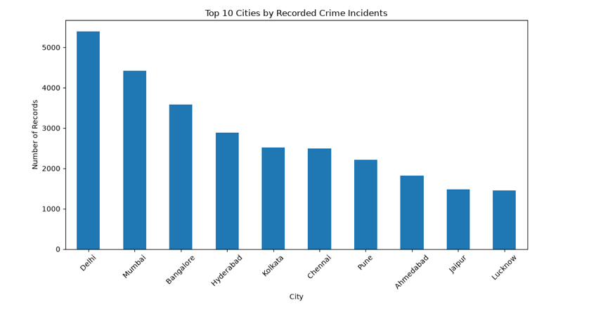

The bar chart shows that Delhi has the highest number of recorded crime incidents among the top 10 cities, followed by Mumbai and Bangalore. Lucknow and Jaipur have the lowest counts among the cities displayed. The graph highlights differences in recorded crime incidents across these cities in the selected dataset. It has use head(10) to display top most values.

Crime Reports by Year
In this graph, we have shown how many crime reports were recorded in each year. The years are shown on the horizontal axis, and the number of reports is shown on the vertical axis. By looking at the bars, we can compare which years had more reports and which years had fewer reports. This helps us understand how the number of recorded reports changed over time.

Crime Occurrences by Year
This graph shows the number of crimes according to the year in which they happened. We used the Date of Occurrence column for this graph. Each bar represents a year, and its height shows the number of recorded incidents in that year. This helps us compare crime occurrences across different years.

Crime Incidents by Hour
In this graph, we have shown crime records according to the hour of the day. The horizontal axis shows the hours, while the vertical axis shows the number of recorded incidents. Each bar helps us see how many incidents were recorded during a particular hour. By comparing the bars, we can understand how the records are spread throughout the day.

Cities by Recorded Crime Incidents
This graph compares recorded crime incidents across different cities. Each bar represents a city, and the height of the bar shows its number of records. In our top 10 cities graph, Delhi had the highest number of records, followed by Mumbai and Bangalore. Lucknow and Jaipur had fewer records among the cities shown. This comparison is based on our dataset and does not directly show which city is actually safer or more dangerous.

Crime Codes
This graph shows the number of records under different crime codes. Each bar represents a crime code, and its height shows how many times that code appears in the dataset. By comparing the bars, we can see which codes have more recorded cases and which have fewer. This makes it easier to understand the distribution of crime records by code.

Crime Descriptions
This graph shows different crime descriptions and the number of records under each description. Each bar represents a crime description, and taller bars show more records. By looking at the graph, we can compare the different types of crimes recorded in the dataset. This helps us understand how the records are divided among the crime descriptions.

Victim Age Distribution
This graph shows the ages of victims and how often each age appears in the dataset. The horizontal axis shows the age groups or ages, and the vertical axis shows the number of records. The graph helps us see which age ranges appear more often in the data. The recorded victim ages range from 10 to 79 years.

Victim Gender Distribution
This graph shows the number of crime records for different victim genders. Each bar represents a gender category, and its height shows the number of records in that category. By comparing the bars, we can understand how the recorded cases are distributed among the available gender categories.

Weapon Used Distribution
This graph shows the different weapon categories recorded in the dataset. Each bar represents a weapon category, and the height shows the number of records for that category. Missing weapon information is also shown separately so that it is not confused with a known weapon type. We found that 5,790 records had missing weapon details, which means the weapon information was not available for every case.

Crime Domain Distribution
This graph shows the number of records in each crime domain. The different domains are shown as separate bars, making it easy to compare them. Taller bars represent domains with more recorded cases, while shorter bars represent domains with fewer records. This helps us understand how the recorded incidents are divided among the crime domains in our dataset.

Police Deployed Distribution
This graph shows the distribution of the values recorded in the Police Deployed column. The bars help us compare how often different values appear in the dataset. This gives us a simple view of the recorded police deployment data. The graph describes the values available in the dataset and does not by itself explain why those values are different.

Case Status Distribution
This graph compares cases marked as closed and not closed. Each bar represents one case status, and its height shows the number of records in that category. Our dataset contains 20,062 closed cases and 20,098 cases marked as not closed. The graph makes it easy to compare both groups and understand the case status information available in the dataset.

Case Closure Duration Distribution
This graph shows how many days were taken to close cases when both the report date and closing date were available. The horizontal axis shows the closure duration in days, and the vertical axis shows the number of cases within each duration range. The graph helps us understand whether the recorded cases were closed within shorter or longer periods. Cases without a closing date were not included in this duration calculation.

Month-wise Crime Occurrences
This graph shows the number of recorded crime incidents in different months, based on the Date of Occurrence column. Each bar represents a month, and its height shows the number of incidents recorded for that month. By comparing the bars, we can see which months have more records and which have fewer. This helps us understand the monthly distribution of crime incidents in the selected dataset.
The graph are in jupter notebook and there is reository link paste in below of report This section contains graphs and each and every graph consits a better understanding solution for every problem through these graphs everyone can esiesly understand the data and go through the solution it conation 15 parts each part conatain a graph ex- age of victim crime occrance according month wise year wise etc graph are the best way of visualising the data and through these graphs you can visualise data easily. we used different graphs to show crime data in an easy way. We created graphs for crime records by year, cities, crime codes, crime descriptions, victim age, gender, weapons used, crime domain, police deployment and case status. We also used graphs to understand crime occurrence by hour and month, case closure duration, and the relation between victim age and police deployment. These graphs helped us compare the data, understand patterns, and find useful information from the dataset.

6. Statistical Analysis (Basic)
We use Statistical analysis in this we use statistical analysis to understand our crime data. We checked the average age of victims, compared crime records of different cities, and calculated percentages. We also checked missing values and unusual age values. We calculated how many days cases took to close and checked if victim age had any relation with police deployment. We used these methods to understand our data better. We did not use any machine learning model in this project.
Descriptive Statistics of Victim Age , Mean, Median and Mode of Victim Age
We used descriptive statistics to understand the age of victims in our dataset. We checked the total number of records, average age, minimum age, maximum age, and other values. The dataset contained 40,160 records, and the victim ages ranged from 10 to 79 years. This helped us understand the age details of the victims in the recorded cases. And We calculated the mean, median, and mode of victim age to understand the age data in different ways. The mean shows the average age, the median shows the middle value, and the mode shows the most repeated age. We used these values to get a better idea of the victim age distribution in our dataset.
Statistical Analysis of Crime Records by City
We checked the number of crime records in different cities and calculated basic values such as the highest count, lowest count, and average number of records per city. This helped us compare the cities according to the records available in the dataset. We used this analysis to understand the differences in recorded crime incidents across cities.
Victim Gender Distribution: Counts and Percentages
We counted the records for different victim genders and calculated their percentages. The counts show the number of records in each gender category, while the percentages show their share of the total records. We used this analysis to understand how the recorded cases were distributed among the available gender categories.
Case Closure Status: Counts and Percentages
We checked the Case Closed column and counted the cases marked as "Yes" and "No". The dataset contained 20,062 closed cases and 20,098 cases marked as not closed. We also calculated the percentage of both categories to compare them easily. This helped us understand the case status information in our dataset.
Statistical Analysis of Case Closure Duration
We calculated the number of days between the report date and the closing date for cases where both dates were available. We then checked basic statistics to understand how long these cases took to close. This analysis helped us study the time taken to close the recorded cases. Cases with missing closing dates were not included in this calculation.
Missing Values Statistical Summary
We checked the number of missing values in each column of the dataset. We found 5,790 missing values in the Weapon Used column and 20,098 missing values in the Date Case Closed column. We also checked the other columns to understand where information was missing. This helped us understand the quality of the dataset before using it for further analysis.
Correlation Analysis: Victim Age and Police Deployed
We checked the correlation between Victim Age and Police Deployed to see if there was a linear relationship between these two columns. The correlation value was approximately 0.00, which means that we found almost no linear relationship between them in our dataset. We used this analysis to understand whether changes in one variable were associated with changes in the other. This result does not prove that there is no relationship of any kind
CorrelationHeatmap
We created a correlation heatmap to show the correlation values between Victim Age and Police Deployed in a visual form. The heatmap showed a value of approximately 0.00 between the two variables. The diagonal values were 1.00 because each variable has a perfect correlation with itself. This graph helped us understand the correlation results more easily.

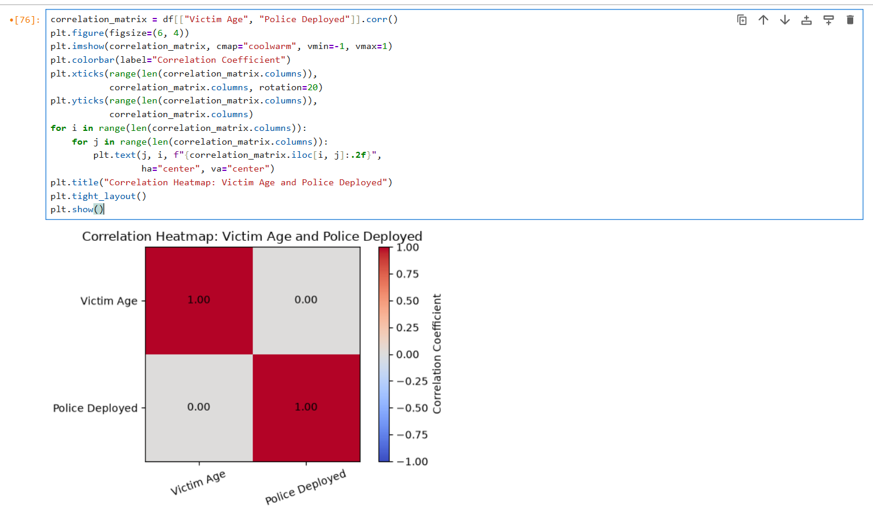
Scatter Plot: Victim Age vs Police Deployed
We created a scatter plot to show Victim Age and Police Deployed together. Each point represents a record, and the different colors show the recorded Police Deployed values. We used this graph to check whether the points showed any clear pattern between victim age and police deployment. Along with the correlation result, the graph helped us understand the relationship between these two variables in the dataset.

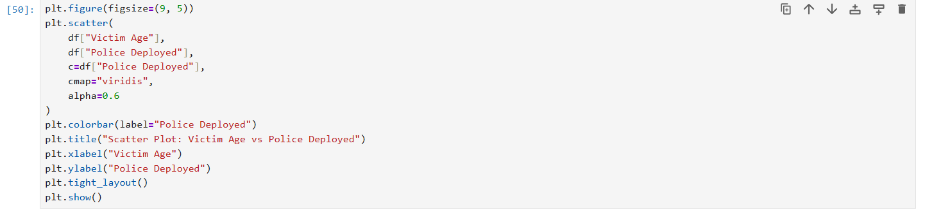
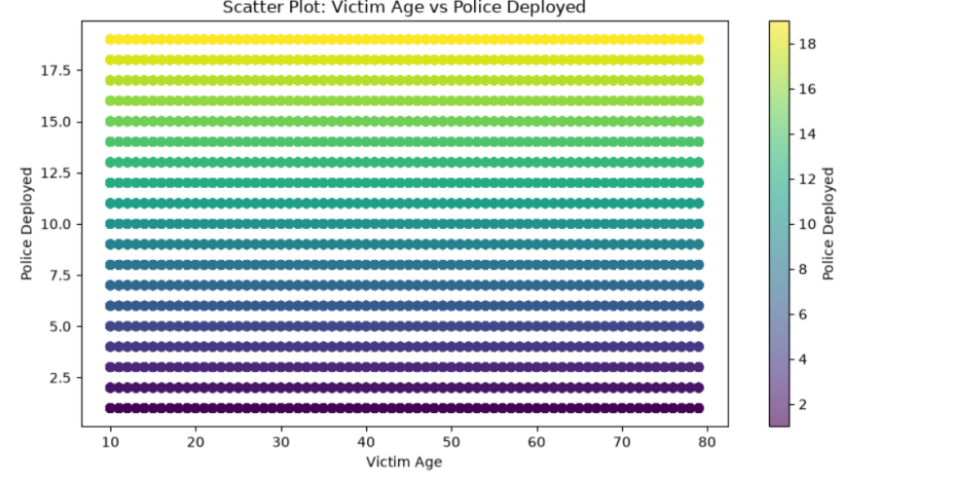
In this project, we used data cleaning to check missing and duplicate values EDA to understand crime data and data visualisation to show the results through graphs. We also used statistical analysis to calculate average values and percentages, outlier analysis to check unusual age values, correlation analysis to check the relation between victim age and police deployment, and case closure analysis to find how many days cases take time to close. These methods helped us to understand the dataset and find the useful patterns without using any machine learning model.

7. Key Insights & Interpretation
- the first key insight is that from data we find cities which as high crime rates city like dehli has topped it and lucknow has lowest crime rate
2. women has to face many crimes most like is the sexual abuse and rape thret etc children have also face crime in an high rate , The dataset contains victims of different ages, from 10 to 79 years. We used age analysis to understand the age distribution of victims.
3. We checked how many cases were closed and how many were still open. This helped us understand the case status recorded in the dataset and the crime codes and crime descriptions to understand which types of crimes are recorded in the dataset. This helped us compare different crime categories.
4. We calculated the time taken to close cases using the report date and case closure date. This helped us understand how long closed cases took to complete and also checked the weapon information to understand which weapons were recorded in different crime cases. Some weapon details were missing from the dataset.
5. We checked the case status and found that the dataset contains both closed and open cases. This helped us understand the current status of the recorded cases.and calculate the time taken to close cases using the report date and case closure date. This helped us understand how long closed cases took to complete.

8. Conclusion & Future Scope
In this project we analysed crime data using Python and different data analysis methods. The main theme of our project is to understand the crime records and find useful information from the given dataset. We find different cities, crime types, crime codes, victim age, victim gender, weapons used, crime domain, police deployment, and case status and We also checked the number of cases reported in different years months and hours.
We used Pandas to read and manage the data and Matplotlib to create different graphs. These graphs helped us understand the data in an easy way and compare different crime records. We also performed data cleaning by checking missing values, duplicate records, and date formats Statistical analysis is use to calculate average values percentages and other basic information. We also checked unusual age values and calculated the time taken to close cases where the required dates were available.
With the help of this project we learned how Python can be used to handle a large dataset and information through graphs. We also understood that data analysis can help us find patterns in the available records and the results depend on the dataset and they do not always show the actual crime situation of a city.
In the future we can improve this project by adding more recent and reliable crime data. We can also use maps to show crime locations and make the project more useful. Machine learning can be added later to study crime patterns and make predictions. therefore this project helped us learn more about Python data cleaning statistical analysis and data visualization.
9. References
List all references, datasets, articles, and tools cited in the project (use a consistent citation style).
- jupyter note book for coding of python librereies pandas numpay matplotib .
- Data analytics usnig python class notes and lerning for betterment
- Youtbue and google for domain knowledge AI for domain knowledge and understanding like Chat gpt ms office for report work
- Github for reposistery link
- Kaggle for dataset download and many government website for crime data set

10. AI Tool Usage Declaration
As per Section 4 & 15 of the PBL guidelines, any use of AI tools (e.g., ChatGPT, GitHub Copilot, Google Colab AI, Gemini, Claude) must be transparently declared below.
☐ No AI tools were used in this project.
☐ AI tools were used, as detailed below:

 | Purpose (e.g., debugging, documentation) | Extent of Use / Section Applied
Chat gpt | Only for domain knowledge it is not use in any other way it is only use ful minor helps when ever we have face any doubt we ask it to chat gpt ex - expalin this term or that term

11. Project Links & Deliverables
GitHub Repository Link: https://github.com/adityaks45/data-analytics-project-crime-hotspot-analysis-and-identification
Python Notebook (.ipynb) File Name: CRIME HOTSPOT ANALYSIS & IDENTIFICATION.ipynb
PBL Report File Name: Data analytics using pyhton pbl report
Confirm that the GitHub repository includes the code, notebook, and a PBL report as required.
☐ GitHub repository includes code, notebook, and a PBL report and README

12. Report Structure Checklist (Section 8 Compliance)
S. No. | Report Section (as per Section 8 format) | Included (✓)
1 | Title Page
2 | Introduction & Problem Statement
3 | Dataset Description & Source
4 | Data Cleaning & Preprocessing
5 | Exploratory Data Analysis (EDA)
6 | Data Visualization & Observations
7 | Statistical Analysis (Basic)
8 | Key Insights & Interpretation
9 | Conclusion & Future Scope
10 | References

13. Declaration by Student(s)
I/We hereby declare that this Mini Project Report is our own original work, prepared using publicly available/open datasets. All sources of data, references, and AI tool assistance have been duly acknowledged. I/We understand that any instance of plagiarism in code or report will attract strict academic action, as per Section 15 of the PBL guidelines.
Team Leader Signature: _____________________________________________
Team Member Signature(s): _____________________________________________
Date: ____________________________________________________________

14. For Faculty Use Only — PBL Final Report Evaluation
Evaluation Component B — PBL Final Report Submission | Mid-Term (PBL Based): 10 Marks (Section 10 of PBL Guidelines)
Evaluation Criteria | Max Marks | Marks Awarded
Data Cleaning & Preprocessing | 2
Exploratory Data Analysis (EDA) | 2
Visualization & Observations | 2
Statistical Analysis | 2
Insights, Interpretation & Conclusion | 2
Total (out of 10) | 10

Faculty Remarks:

Faculty Mentor Signature: _____________________________________________
Date: ____________________________________________________________

